Georgia State Parks and Historic Sites
Independence Day Holiday Weekend Summary
07.06.2020

Holiday Weekend Summary:
- Camping and Cottage occupancy was high for the Independence Day holiday weekend throughout the state and including south Georgia which is unusually lower due to hotter temperatures. Day use traffic was busy but no greater than it has been over the last several months. In fact, some sites had a slight decrease in day use visitation and hiking trail use due to higher temperatures. Historic sites were not as busy as previous weekends but still steady. Picnic shelter rental was up over previous weekends with little distancing issues.
- NGMA - Sites ran high occupancy at lodges, campsites and cottages, all reported strong visitation throughout the weekend.

Crowds:
- Sites that had to temporarily limit day use access due to capacity include: Cloudland Canyon, Ft. Yargo, Red Top Mountain, Sweetwater, Tallulah Gorge and Vogel. Some sites had slightly less day use traffic compared to the last two months. It was a hot weekend in north Georgia, and this may have reduced interest in hiking.

- Golf Course activity was very high for the weekend, 104% higher than last year. The Ogeechee boat ramp at Fort McAllister filled early on July 4th. Several boaters used the park’s day use parking area. The Laura Walker boat ramp was busy with LED responding to a PWC complaint. Red Top Mountain, Elijah Clark, Richard B. Russell, and Mistletoe reported heavy boating usage. A Presidential boat parade drew 100+ boats to Lake Blackshear just outside the park marina. George T. Bagby’s boat ramp filled to capacity and the marina was used for overflow.

- On Friday night, F.D Roosevelt experienced high traffic use on Hwy 190 due to the Fireworks Display at Callaway Gardens. Georgia State Patrol worked traffic at intersections to alleviate the problems on Saturday and Sunday nights. Red Top Mountain also experienced heavy traffic on Friday night at Webster’s Ferry area due to the Firework display from the Allatoona Yacht club.

Staffing issues:
- The Division has 22 part-time and full-time staff out due to COVID-19 related reasons. A total of 33 employees have tested for COVID-19 and 4 were positive, 22 negative and 7 are awaiting results.

Positives
- On Friday, SAM Shortline routed a train ride into Cordele for the first time since late 2018. Due to slow orders limiting the speed, the train was not able to include Cordele into the schedules over the last two years. Using the downtown depot was a welcomed change for the SAM operation!

- Stephen C. Foster’s cottages were full and the campground almost full for the busiest 4th in staff’s memory. This is likely due to people taking “staycations”, taking vacations closer at home in locations such as state parks where they can social distance.

- Fort Yargo was selected as a test site for tablet use at Kiosks. Utilizing a tablet will allow park visitors to pay by credit card at the Kiosk, a huge convenience for our customers. The tablet was in use for the holiday weekend. Although there is processing time, the staff adjusted kiosk operations, increased the number of Kiosk Attendants and these changes improved the speed of customers paying by credit card.

- Website and social media statistics for 6/29-7/5 continued to be high, hopefully a good indication for late summer and fall visitation. Total Pageviews were up 60%, the Reservation pageviews were up 76%, the Alerts Page received 18,137 views. Facebook page followers increased 4% to 312,642

Challenges
- There was a small wildfire at Tallulah Gorge that was extinguished with minimal area burnt.
- On the night of 7/5, Fort Yargo experienced a 4.77-acre wildfire. The park staff, Georgia Forestry Commission, and Winder Fire Department contained and extinguished the fire.
- A family staying at Crooked River climbed over the barrier next to the warning sign on the river bluff. One woman fell and broke her arm and leg. EMS had to evacuate the victim up the bluff.
- Victoria Bryant and Watson Mill staff responded to two medical emergencies on the shoals at Watson Mill on 7/5.
- A tree fell on a camper at Fort McAllister and was reported as possible entrapment. Damage was minimal and no injuries. A responding Game Warden stopped a truck pulling a jet ski with a woman on it. Driver, passenger, and jet ski rider all issued tickets for open containers.
- Several sites reported fireworks and noise issues.
- Distancing was an issue with beach users at Laura Walker and swimming in restricted areas.
- High Falls had one vehicle break-in on Saturday. DNR LED worked the incident.
- Vaughter’s Farm Barn at Panola Mountain experienced a break-in on the night of 7/3 or early morning on 7/4. DNR Law Enforcement is working with the staff on putting up a camera since this was the second recent occurrence.
- On 7/4, Elijah Clark reported an accident with a physical altercation that occurred around the entrance of the park, where local law enforcement was involved.
- George T. Bagby staff responded to a minor domestic incident at the lodge and notified local DNR LE.
- Providence Canyon staff assisted a visitor on Sunday who was experiencing heat exhaustion.
- DNR Law Enforcement and Bartow County officers responded to a domestic at Red Top mountain on 7/5.
- DNR WRD assisted in the removal of a raccoon from the day use area at Indian Springs on Saturday.
- Unicoi staff dealt with a problem bear through most of the weekend at the Smith Creek cabins and the campground. Deterrents were used and WRD arrived to trap the bear on Monday. Unicoi also managed traffic overflow from Anna Ruby Falls and worked with USFS to resolve the backup onto the park.

Financial Update

Past Weekend:
Overall occupancy for all reservables increased 4% this past weekend to 80%. All overnight reservables saw an occupancy increase. Camping increased 2%, reaching 88% occupancy. Yurts were at 97% occupancy, 7% higher than the previous year. Cottage rentals also saw an increase going from 90% to 95%.

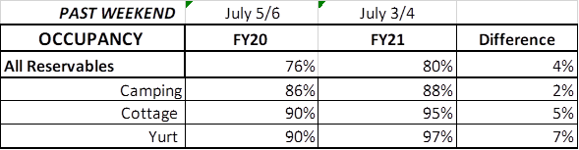

Upcoming Weekend:
For the upcoming weekend, there is already a 9% increase in all reservables at 68% occupancy. Camping is showing a 2% increase, cottages are equal to last year at 88% and yurts are showing an 18% increase to 100% occupancy.

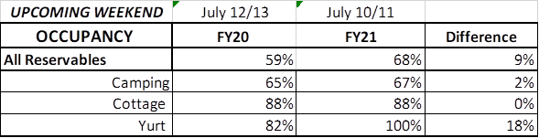

Revenue:
Year to date thru July 5th, park receipts have increased 8% or $2.5 Million over last year. For the 1st week of July, revenue was approximately the same as last year at $707,000. This is the first time in almost 3 months that we did not see a significant increase, which is due to the July 1st change in our reservation booking policy, where we changed from collecting payment in full at the time of booking, to now collecting a 50% deposit.

Overnight accommodations – camping revenue continues to significantly increase. This past week camping improved 24% or $45,000. Although last week, the increase was at 70%. Cottage revenue decreased for the first time in a number of weeks, decreasing 6% or $10,000. Yurts improved 2% or $200.

For the first 5 days in July, ParkPass revenue increased 22% or $24,000 compared to last year.

Golf saw a 104% or $25,000 increase over the July 4th Holiday.

Note:
- As of July 1st, we changed the policy from collecting all revenue at the time of booking to only 50% deposit when booking a reservation. This is the reason for no longer seeing a significant increase to overnight accommodation revenue.

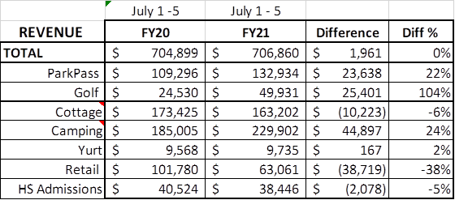

Cancellations/Refunds:
Through this morning, we have had 36,000 reservation cancellations, including $3.2 Million in actual refunds and a loss of future revenue of $14.4 Million. This is 1,000 more than last Monday, when we were at 35,000 cancellations. The significant drop in the number of cancellations continues, as initially we had 4,000 – 5,000 a week, although we continue to see a higher number of cancellations than the previous year. Last year during the same week there were 800 cancellations, thus there was 200 more cancellations this past week than last year during the same time period.

Last year during March thru YTD, there was 14,400 cancellations, including $748,000 in actual refunds and a loss of future revenue of $3.6 Million.

So, total cancellations have increased over 21,600 or 150% and the amount of refunds have increased $2.5 Million.

